Ovo je već “utility-grade” razina — ideš iz IoT simulatora u power system digital twin + ML na grafu. Dajem ti strukturirano kako se to radi u praksi.

1. MULTI-LAYER POWER GRID PHYSICS SIMULATION (LOAD FLOW)

Cilj
Simulirati stvarni tok energije kroz mrežu trafostanica:
- naponi po čvorovima
- tokovi snage po vodovima
- gubici
- overload linija
- kaskadni pad (blackout propagation)
Ovo je klasični load flow problem (power flow).

Model mreže (graf)
Tvoj sustav trafostanica = graf:
- čvor = trafostanica
- edge = vod (kabel/linija)
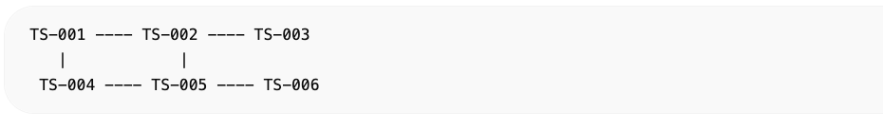

Multi-layer model (ključna ideja)
Svaka trafostanica ima 3 sloja:

1. Physical layer (elektrika)
- napon (V)
- struja (I)
- impedancija
- power flow

2. Thermal layer
- temperatura transformatora
- gubitci (I²R)

3. Stress layer
- opterećenje
- degradacija
- failure risk

Simplified load flow model (DC approximation)
Koristimo DC power flow (industrijski standard za fast simulation):

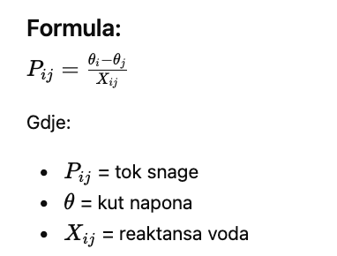

Python simulacija (core engine)

1. Grid model
import numpy as np  class GridNode:  def __init__(self, id):  self.id = id  self.voltage = 1.0  self.angle = 0.0  self.load = 0.0  self.gen = 0.0  class GridEdge:  def __init__(self, a, b, x):  self.a = a  self.b = b  self.reactance = x  self.flow = 0.0 | 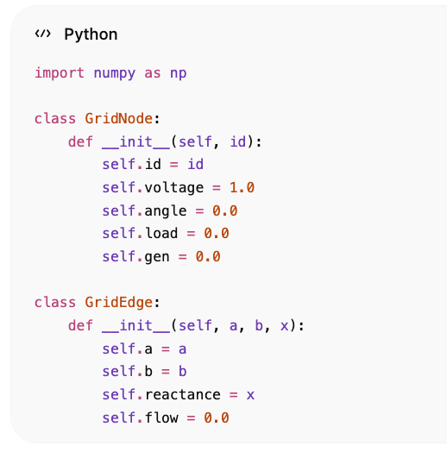

2. Power flow solver (iterativno)
def compute_power_flow(nodes, edges):  for e in edges:  a = nodes[e.a]  b = nodes[e.b]  e.flow = (a.angle - b.angle) / e.reactance  # overload detection  if abs(e.flow) > 1.0:  e.overloaded = True | 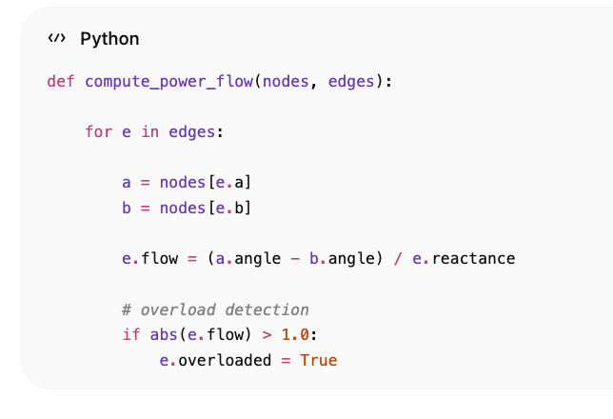

3. Voltage update (simplified)
def update_voltages(nodes):  for n in nodes.values():  n.voltage -= n.load * 0.01  if n.voltage < 0.95:  n.stress = "HIGH" | 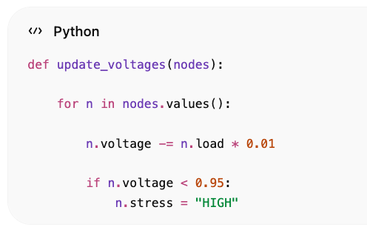

Thermal coupling (ključ za transformer aging)
def thermal_model(node):  loss = node.load ** 2 * 0.01  node.temperature += loss  if node.temperature > 90:  node.degradation += 0.05 | 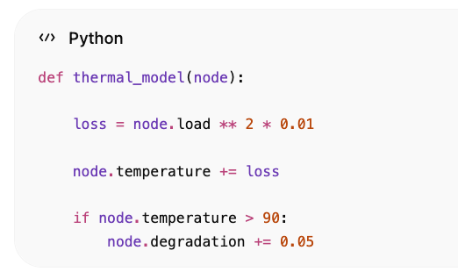

️ Blackout propagation
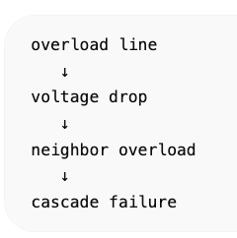

2. GRAPH NEURAL NETWORK (GNN) ZA TRAFOSTANICE
Ovo je “AI layer” iznad fizike.

Cilj GNN-a
Model uči:
- gdje će nastati kvar
- koji node je kritičan
- kako se širi blackout
- predviđa load + failure

Graf definicija
- V = trafostanice
- E = vodovi
- features = senzori

Node features
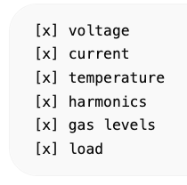

Edge features
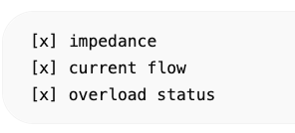

GNN arhitektura
Koristimo standard:
Graph Convolutional Network (GCN)

Formula:
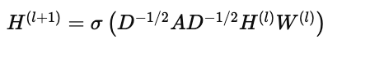

PyTorch Geometric model
import torch  import torch.nn as nn  from torch_geometric.nn import GCNConv  class GridGNN(nn.Module):  def __init__(self, in_channels):  super().__init__()  self.conv1 = GCNConv(in_channels, 32)  self.conv2 = GCNConv(32, 16)  self.out = nn.Linear(16, 1)  def forward(self, x, edge_index):  x = self.conv1(x, edge_index)  x = torch.relu(x)  x = self.conv2(x, edge_index)  x = torch.relu(x)  return self.out(x) | 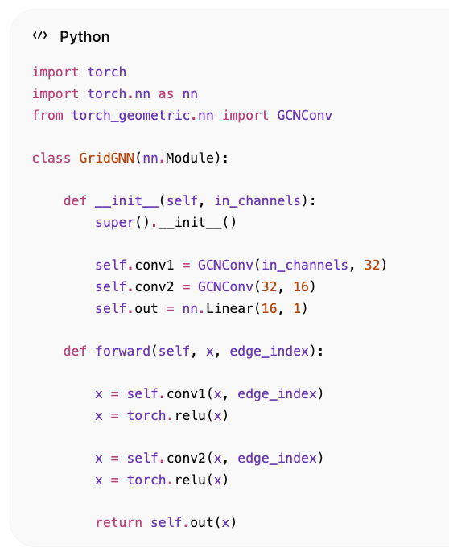

GNN OUTPUT

1. failure probability
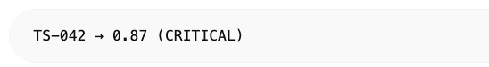
TS-042 → 0.87 (CRITICAL)

2. load prediction
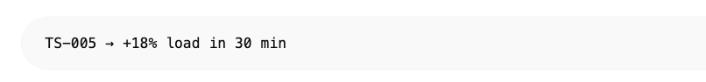
TS-005 → +18% load in 30 min

3. cascade risk
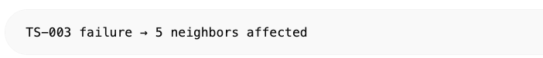
TS-003 failure → 5 neighbors affected

COMBINED SYSTEM (FIZIKA + AI)
Ovo je ključ:
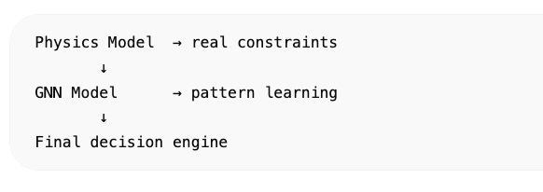
Physics Model → real constraints
↓
GNN Model → pattern learning
↓
Final decision engine

DIGITAL TWIN U PRAKSI
Svaka trafostanica ima:

Real state
- EMQX senzori

Physics state
- load flow model

AI state
- GNN prediction

Final health score
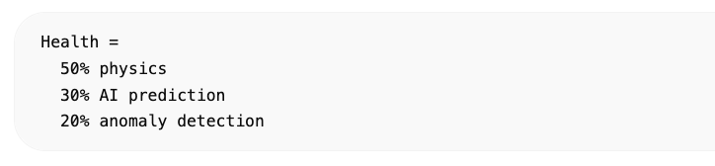

BLACKOUT SIMULATION ENGINE (FULL SYSTEM)
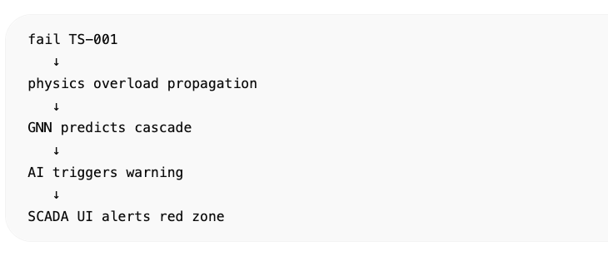

ŠTO SI SAD DOBIO
Ovo je već:

INDUSTRY DIGITAL TWIN STACK

Physics layer
- load flow simulation
- voltage propagation
- thermal coupling

AI layer
- Graph Neural Network
- failure prediction
- load forecasting

SCADA layer
- realtime monitoring
- geo visualization
- alarm system

